**Assignment 4 Week 2**

**Name:- Tushar arora, Daksh Mehta, Tarun Ashwini, Raju Kumar, Swati Sima Simboda and Parth Gala.**

**Question:- Select at least one campaign to recommend for removal?**

**Answer:- I need to suggest campaigns 3,10 and 4 to remove them.**

**WHY:-**

**The main factor that depends on effectiveness of ads is CPC, CPR and one more factor is that campaigns get clicks and unique clicks with less money spent.**

**Campaign 3, 10 and 4 got high CPC and CPR, which means not profitable campaigns.**

**Campaign 3, 10 and 4 got low click and unique click with spent money.**

**Let's see according to Geography.**

**Campaign 1 and 2 has high spending money because the ads are going on in a group of geography. Except group 1 and 2(group) Nigeria and India got better results or got many unique clicks with a log of amount spent. Australia and the UK are not well for ads according to CPC , CPR and get low click with spend of money.**

**Let’s see the graph.**

**1st Approach:- We need to find the Campaign that got high CPC and CPR.**

**CPC:- The average cost of one click on the ad. This can be used to measure how effective an ad campaign is.**

**CPR = Total amount spent / total number of results (unique link-clicks).**

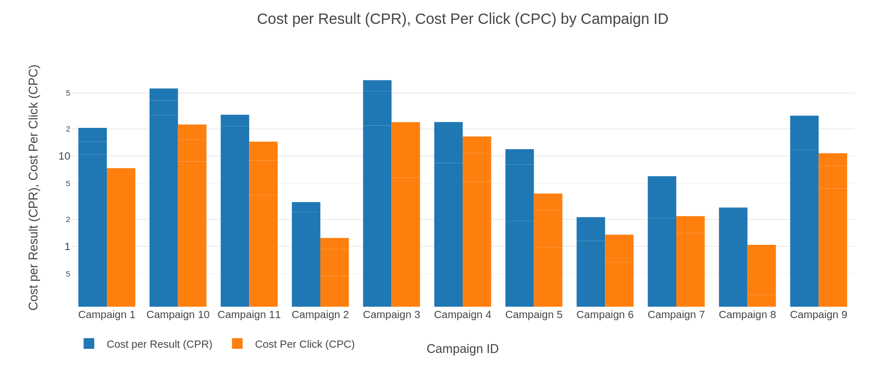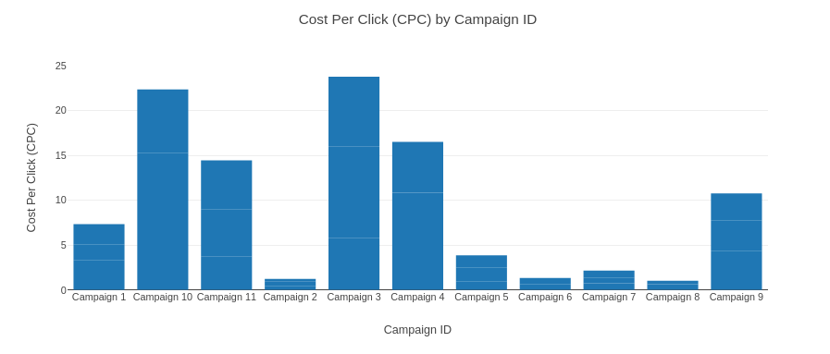

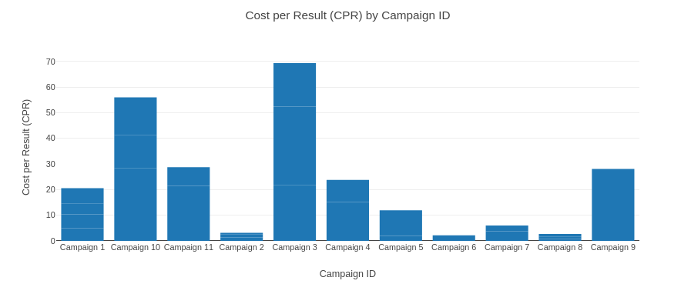

**Conclusion:- Campaign 3 and 10 got high CPC and CPR.**

**2nd Approach:- We need to find the Campaign that got a low clicks and unique clicks with spent money.**

**We observe that, Except campaign 1 and 2, all campaigns are in the same range according to spend. Because campaign 1 and 2 contain groups of geography.**

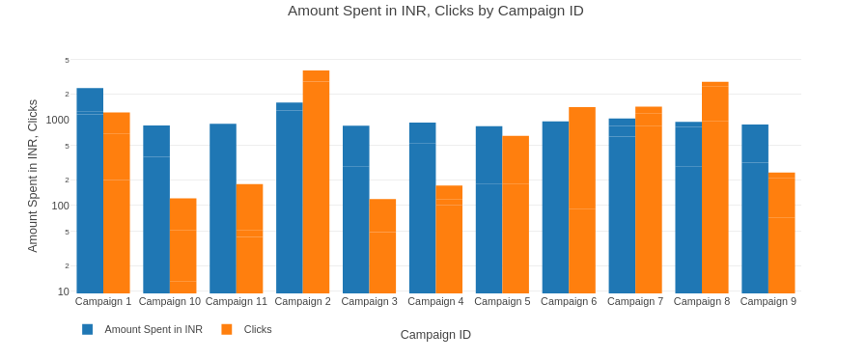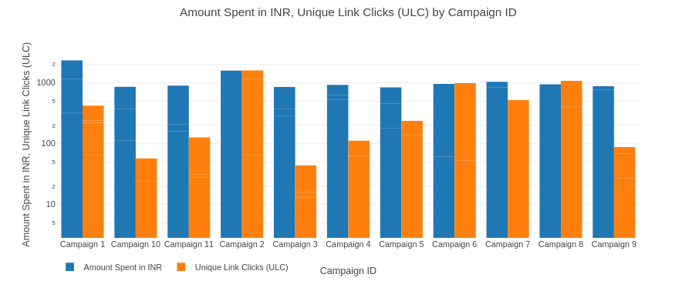

**Conclusion:- Campaign 3, 10 and 4 got low clicks and unique clicks with respect to spending score.**

**Both approaches with Geography:- We need to find the Geography that got low click and unique clicks with spent money.**

**We observe that, Except campaign 1 and 2, all campaigns are in the same range according to spend. Because campaign 1 and 2 contain groups of geography.**

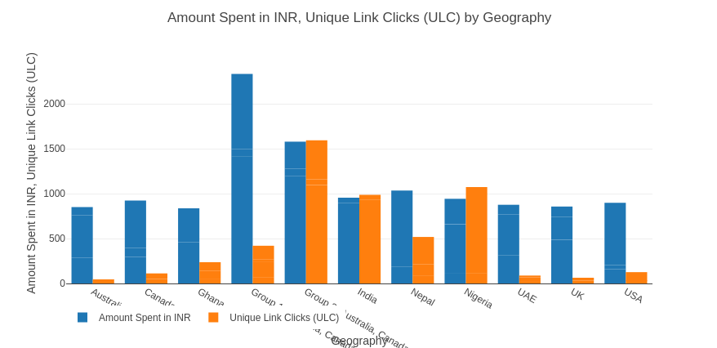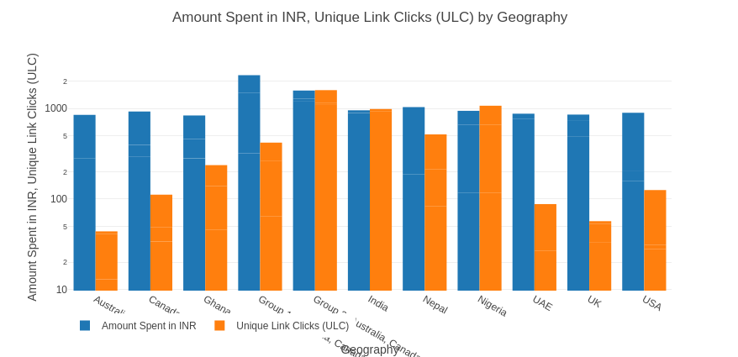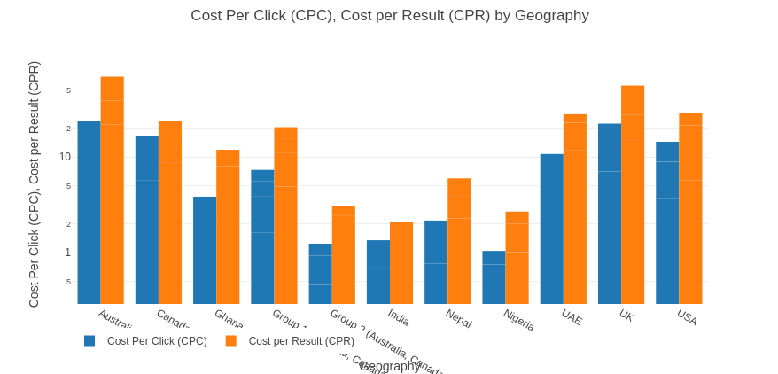

**Conclusion:- Except group 1 and 2, India and Nigeria got better results or low CPC and CPR. Australia, UK and USA got High CPC and CPR, It means these are not profitable geography.**

**According to Clicks and spend of money, xcept group 1 and 2, India and Nigeria got better results or high clicks in spend of money. Australia, UK and USA got low click and unique clicks, It means these are not profitable geography.**

**Audience is students.**

